Authors
Neal Evans – People Information, Philip Makin – Equality, Diversity and Inclusion Coordinator,
Cathy Walsh - Associate Director Patient & Carer Experience
Gender Pay gap
report
September 2021


Gender Pay Gap Report 2021

Foreword
From 6 April 2017 employers in Great Britain with more than 250 staff are required to publish their gender pay gap information annually, using six different measures, covering pay and bonuses. This report provides a snapshot of pay data on 31st March 2021, which is also published on the Gender Pay Gap Reporting pages of the Gov.uk website. The purpose of the reporting is to increase awareness, improve pay transparency and to encourage actions in relation to closing the gap.

What is the Gender Pay Gap?
The gender pay gap is a measure of the difference between men’s and women’s average earnings across an organisation, regardless of the nature of their work and it is expressed as a percentage of men’s earnings.
It is important to distinguish between the gender pay gap and equal pay. Equal pay concerns differences between the actual pay of male and female employees doing equal work or work of equal value. An organisation may be an equal pay employer, paying male and female staff equally for doing equal work, and it may still have a gender pay gap. The Trust employs staff across a range of roles and adheres to the appropriate national NHS Medical and Dental Pay and Conditions and the national NHS job evaluation framework within Agenda for Change. All pay scales provide a process for paying employees equally regardless of gender for the same or equivalent work.

How do we calculate the Gender Pay Gap?
The snapshot date for this report being 31st March 2021 for ordinary pay and a whole 12 month period from 1st April 2020 to 31st March 2021 for bonus pay. For gender pay gap reporting, employees are those employed under a contract of employment to do work. This includes those under Agenda for Change terms and conditions, medical staff and very senior managers (VSM), those employees on other terms and conditions following a transfer under TUPE legislation and any Bank Staff who received pay on 31st March 2021.
The requirement is to publish six key measures of the gender pay gap:
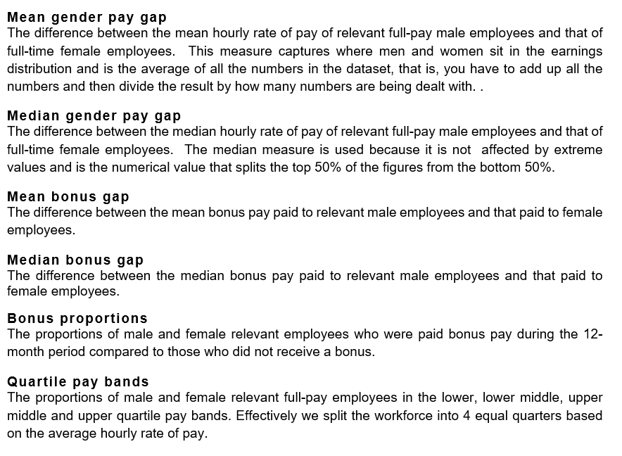

What is the Trust’s Gender Pay Gap?

Current Staff in Post
Overall, as an organisation, the Trust employs more women than men as is seen across many NHS Organisations. The Trust employed 4148 ‘relevant employees’ and 4020 ‘full-pay relevant employees’ as of 31st March 2021, this figure includes 292 bank-only workers who were paid in March 2021 and therefore have been used as part of the calculation of the gender pay gap information. 3187 (79%) were female and 833 (21%) were male.

Ordinary Pay
The Trust’s mean gender pay gap for average hourly pay is 15.40%. This is lower than the national public sector average of 15.8% as identified by the Office for National Statistics Annual Survey of Hours and Earnings published 7th December 2020. When comparing our median figure, the Trust has a 0.43% pay gap compared to the national public sector average of 14.5%.
 | Female | Male | Difference | Pay Gap % | National Public Sector Pay Gap %
Mean Hourly Rate | £17.4621 | £20.6402 | £3.1781 | 15.40% | 15.80%
Median Hourly Rate | £16.0402 | £16.1089 | £0.0687 | 0.43% | 14.50%

The Trust

When reporting the pay gap for all staff employed at the snapshot date the Trust’s mean hourly pay gap is 15.40% and the median pay gap is 0.43%.

Highlighting Staff on Agenda for Change Terms and Conditions
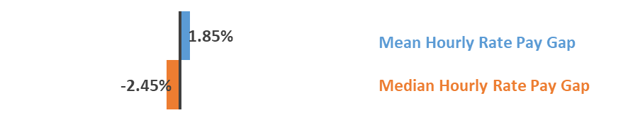
When reporting solely on staff that are on Agenda for Change terms and conditions the mean hourly pay gap is 1.85% and the median -2.45%.

Highlighting Staff on Executive Team
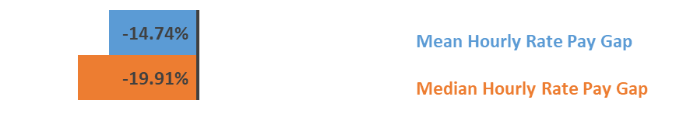
When reporting solely on staff that are on Executive terms and conditions the mean hourly pay gap is
-14.74% and the median -19.91%.

Highlighting Staff on Medical Terms and Conditions

When reporting solely on staff that are on medical terms and conditions the mean hourly pay gap is 9.04% and the median 12.48%.

Highlighting Staff on Local Terms and Conditions

When reporting solely on staff that are on Local terms and conditions the mean hourly pay gap is 5.92% and the median 7.29%.

Further detail regarding the gender pay gap across pay bands, staff groups and comparing year 16/17 to 20/21 is provided in the appendices 1 and 2.

Bonus Pay
Bonus pay includes Clinical Excellence Awards and Recognition of Service Awards paid between 1 April 2020 and 31 March 2021 for all relevant staff. Please note payments are only included where pay was due for the reporting period, any arrears payments are excluded from the total amount before calculating the pay gap. During the year, 169 staff received these payments with the median amount for women being £150.00 and for men £3,177.00 with a pay gap of 95.3%. The mean average amount was £2,452.08 for women and £6,691.99 for men with a pay gap of 63.36%.
 |  |  |  |  | % of trust staff by gender who received bonus
 | Female | Male | Difference | Pay Gap | % Female | % Male
Average Bonus Pay Value | £2,452.08 | £6,691.98 | £4,239.90 | 63.36% | 3.37%  111 out of 3296 | 6.81%  58 out of 852
Median Bonus Pay Value | £150.00 | £3,177.00 | £3,027.00 | 95.3% | 3.37%  111 out of 3296 | 6.81%  58 out of 852
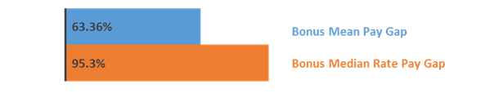
Highlighting on Recognition of Service Awards
101 staff received recognition of service award vouchers where the median for both men and women is £100, with the pay gap as 0.00% for these awards in isolation. The mean average amount was £124.38 for women and £126.19 for men with a pay gap of 1.4%.
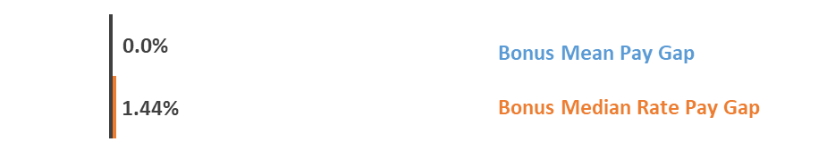
Highlighting on Clinical Excellence Awards

69 staff received Clinical Excellence Awards. When looking at these payments alone, the median amount for women being £3,880.72 and for men was £4,986.60 with a pay gap of 22.2%. The mean average amount is £8,120.51 for women and £9,676.40 for men with a pay gap of 16.1%.
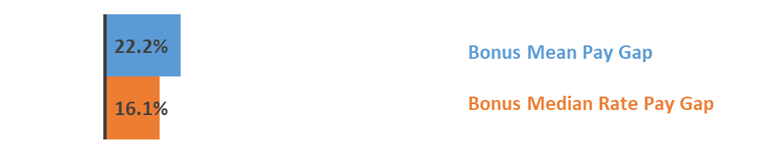

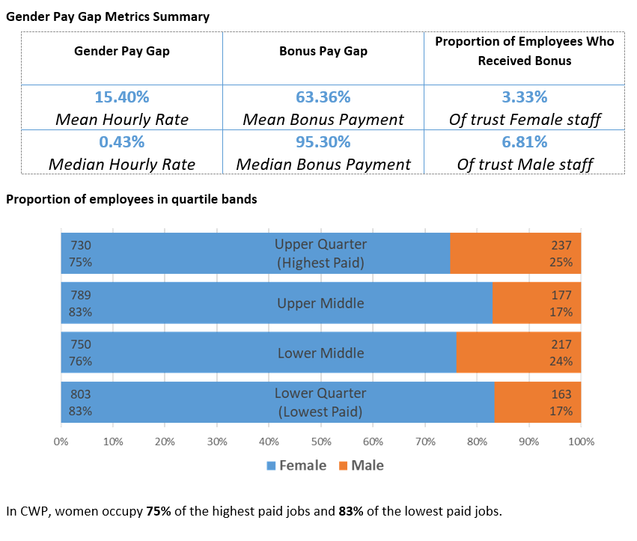
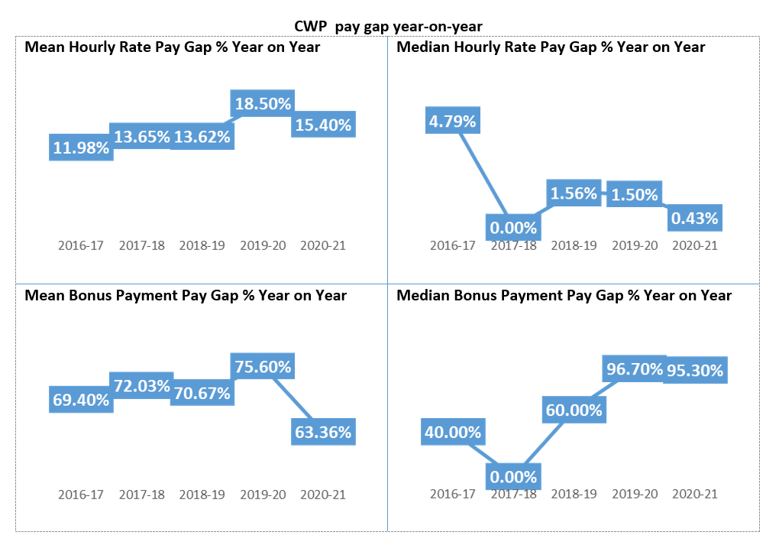
Key findings

Ordinary Pay Gap
- The pay gap of 15.40% is in favour of males but has reduced from 18.50% and the Trust is continuing to work towards narrowing this further.

- The Trust employs significantly more female staff; 79% of our workforce is female. The Trust has a lower proportion of females in the Lower Middle and Upper quartiles where 76% and 75% are female respectively – highlighting where there is a larger male workforce.

- The Trust is awaiting the national public sector mean pay gap for 2021 to be published to examine where the Trust is comparably. Currently the Trust’s pay gap of 15.4% is below the national rate of 15.8% (latest available year was published in December 2020).

- The pay gap specifically for staff on Agenda for Change terms and conditions however is broadening and is currently 1.58%. This has increased from 0.91% in the 2018-19 year.

- In the production of the 2019-20 Gender Pay Gap report, the Trust identified that an incorrect calculation was made when calculating the hourly pay rate of GPs in our Out of Hours service, which resulted in a spike for the 2019-20 year of 18.50% mean hour rate.

- Through engagement with female medical staff, the Trust has supported them with applications for Clinical Excellence Awards. The awards for 2019-20 were paid in April 2020 and therefore the trusts approach to making these payments equitable can be seen to have contributed to the reduction in the bonus pay gap.

- Through further detailed analysis of the pay gap within each Banding and Staff Group on NHS Agenda for Change terms and conditions, the organisation have identified some specific groups of staff that have a higher-than-average ordinary pay gap – further detail in appendix 4.

Bonus Pay Gap
- The bonus pay gap has reduced from 75.60% to 63.36%.

- There is no national comparator for national public sector bonus pay gap.

- The Trust identified previously that the Clinical Excellence Awards to medical staff were potentially inequitable as fewer females applied for these awards each year. Work completed in 2019-20 and subsequent payments made in April 2020 has culminated in a reduction in the bonus gender pay gap.

- The median bonus pay gap specifically for Clinical Excellence Awards has reduced year on year from 68.01% in 2018-19 to 16.10%.

- The mean bonus pay gap for Clinical Excellence Awards has reduced from 32.17% in 2018-19 year to 22.20% - see appendix 3.

The next steps
The Trust’s mean hourly gender pay gap is now lower than the national public sector gender pay gap, exploring where this exists for each band and staff group will assist in identifying future improvement work. In addition, work will continue to address the payment issue in the gender gap in bonus payments. Key drivers for the gender pay gap are understood to be the result of various factors outside the control of individuals, for example unpaid carer responsibilities could be a consideration. The Trust is committed to workforce equality and the following actions have been incorporated into the Trust’s People Plan for 2021/22:
- Strengthening of unconscious bias training for recruiting managers including refresher training.

- Creation of a Task and Finish group to review the flexible working policy and access to flexible working opportunities which will lead to raising awareness.

- Development of a talent management programme to support all employees with their career development, which may be outside of their current role.

- Promotion of development opportunities such as Apprenticeships and regional training.

- Continued promotion of Clinical Excellence Awards opportunities to increase applications from female medical staff.

- Re-visit the development programme for people to shadow senior leaders and executive board members.

- Further publicise story telling by people working at VSM level within the Trust.

- Implement the programme of Reciprocal Mentoring Programme.

- Raising these subject areas in the agendas of the staff network groups and consider any relevant or related output information from the Trust’s ‘Imagining the Future’ engagement programme.

Appendix 1 – Average Hourly Rate by Pay Groups
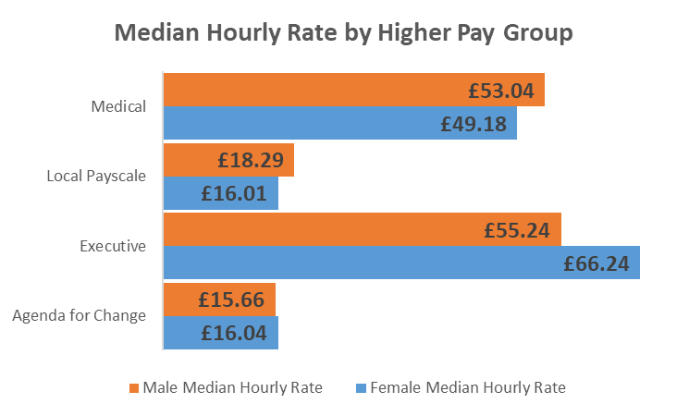
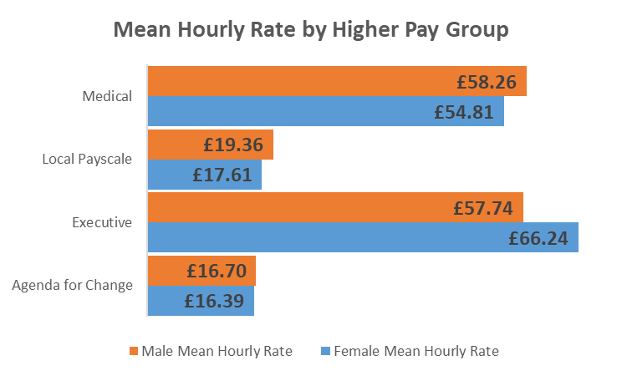
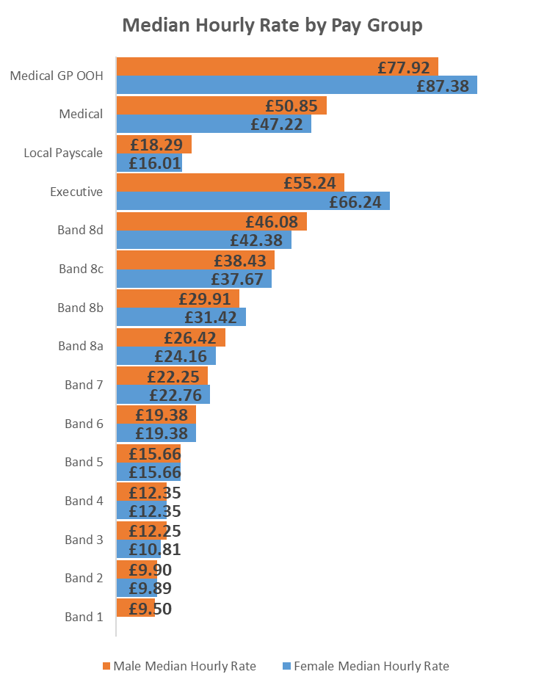
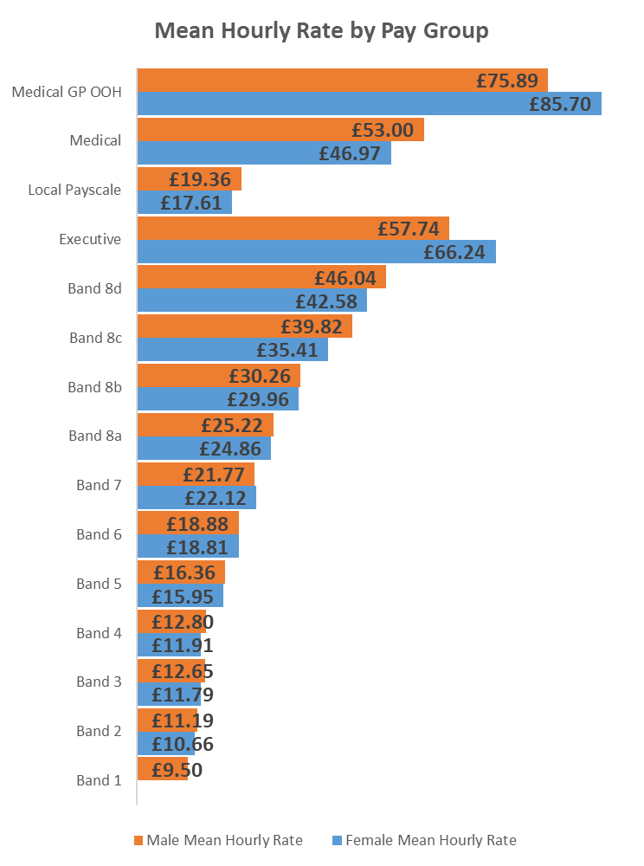

Appendix 2 – Average Hourly Rate by Pay Groups – Year on Year
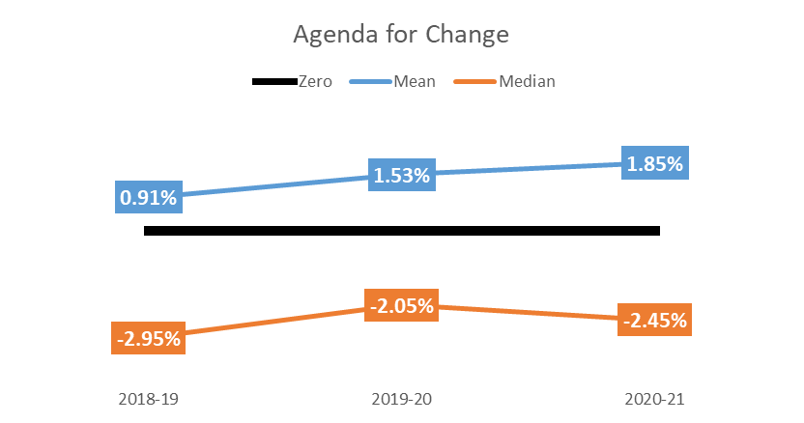 | 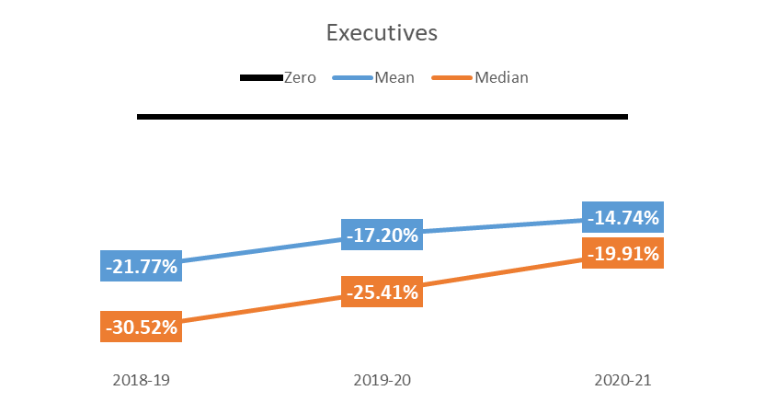
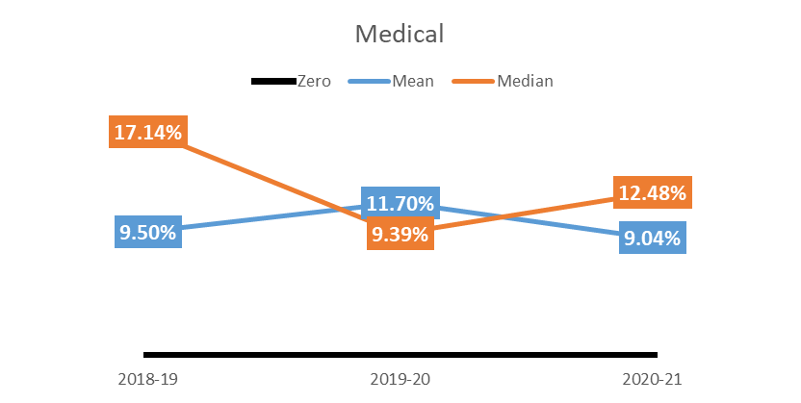 | 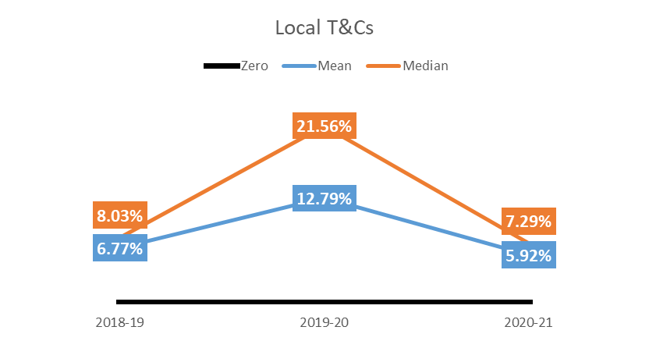
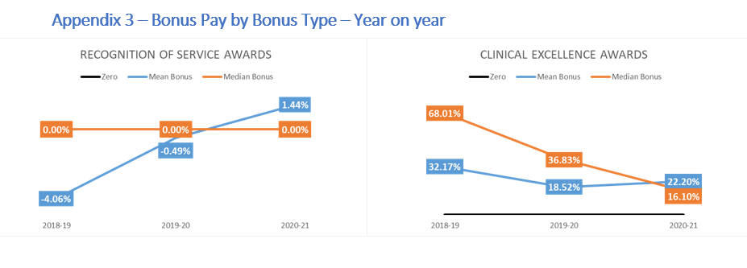

Appendix 4 – Pay Gaps within specific AfC Bands and Staff Group
Band / Staff Group | Mean Hourly Rate |  |  |  | Median Hourly Rate
Band / Staff Group | Female | Male | Difference | Pay Gap % | Female | Male | Difference | Pay Gap %
Band 3 - Estates and Facilities | £10.89 | £12.76 | £1.86 | 14.59% | £10.81 | £12.41 | £1.59 | 12.84%
Band 4 - Estates and Facilities | £12.91 | £14.74 | £1.83 | 12.40% | £13.11 | £14.97 | £1.86 | 12.41%
Band 5 - Estates and Facilities | £0.00 | £17.30 |  |  | £0.00 | £17.42
Band 5 - Addt. Prof. Tech | £13.97 | £15.64 | £1.67 | 10.65% | £12.74 | £15.66 | £2.92 | 18.64%
Band 6 - Admin | £17.93 | £18.32 | £0.39 | 2.14% | £17.27 | £18.87 | £1.59 | 8.44%
Band 7 - Addt. Clinical Services | £21.09 | £24.01 | £2.91 | 12.13% | £21.13 | £24.01 | £2.88 | 12.00%
Band 8a - Addt. Prof Tech | £24.44 | £26.42 | £1.98 | 7.50% | £24.10 | £26.42 | £2.32 | 8.79%
Band 8a - Admin | £25.02 | £25.00 | -£0.02 | -0.08% | £24.50 | £26.42 | £1.93 | 7.29%
Band 8b - Nursing | £28.45 | £32.48 | £4.03 | 12.41% | £27.62 | £32.48 | £4.87 | 14.99%
Band 8c - Addt. Prof Tech | £36.07 | £41.67 | £5.60 | 13.44% | £37.67 | £38.13 | £0.46 | 1.21%
Band 8c - Admin | £34.81 | £37.35 | £2.54 | 6.81% | £33.20 | £38.43 | £5.22 | 13.60%
Band 8a - Admin | £42.00 | £46.43 | £4.43 | 9.53% | £39.74 | £46.39 | £6.65 | 14.33%

