**Photograph Consent Form**



We would like to take your picture

(explain here ……..)



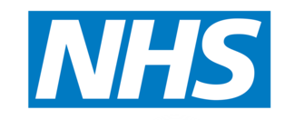We would like to use your photograph:

* On our NHS internet site
* On social media – this would be Twitter and Facebook

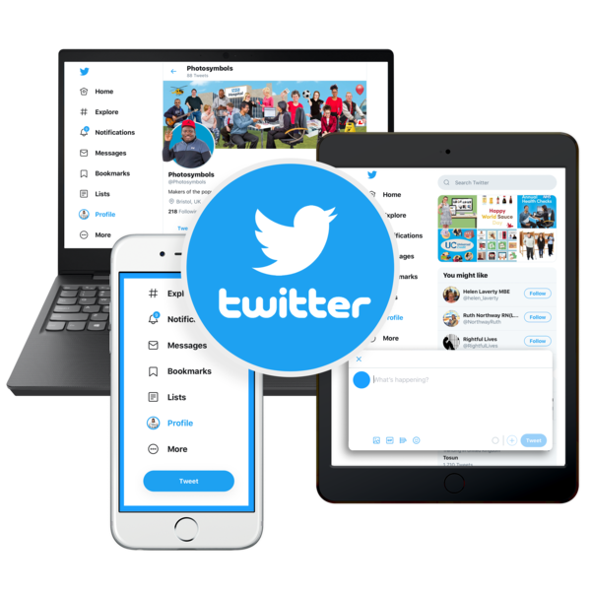

This means that lots of people will be able to see your photograph.

It has been explained to me that I can change my mind at any time and my photographs will be removed from the website.

But staff will not be able to stop any information that people already have that has photographs of me in it.

I am happy for my photographs to be used.

My name …………………………………………………….

Date: …………………………………………………………..

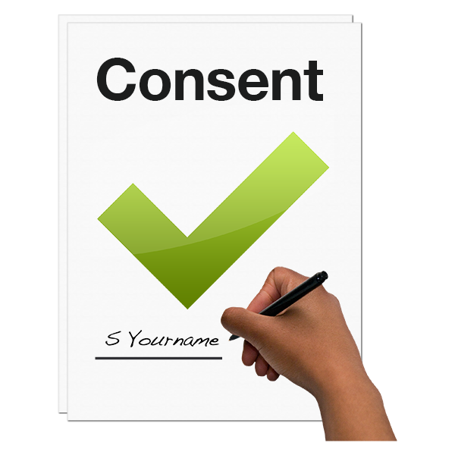

How the photographs will be used and who might see them was explained by

Staff name …………………………………………………….

Date: …………………………………………………………..